

**NCC Education**

**Level 5 Diploma in Computing**

**Dynamic Websites**

|  |  |  |  |
| --- | --- | --- | --- |
| Centre Name | : | MCC Training Institute (Yangon Campus) | |
| Assignment Title | : | Wild Swimming and Camping Website | |
| Exam Cycle | : | Spring – Winter 2023 | |
| Candidate Name | : | Zeyar Paing | |
| NCC Education ID No. | : |  | |
| Submission Date | : | 27.04.2023 | |
| Marker’s Comment | : |  | |
| Moderator’s Comment | : |  | |
| Mark: |  | Moderated Mark: | Final Mark: |

Table of Contents

Task 1 – HTML 4

Home Page 4

Information 5

Pitch Types and Availability 6

Reviews 7

Features 8

Contact 9

Local Attractions 11

Login Page 12

Register Page 14

Cross Platform and Cross Browser Usability 16

Home Page 16

Pitch types & Availability (Explore) 18

Contact form 20

Task 2 – CSS and Database 22

CSS 22

Data Dictionary 23

GWSC Info Table 23

Admin Table 23

User Table 23

Pitch Table 24

Feature Table 24

Local Attraction Table 24

Camping Site 25

Contact Table 26

Review Table 26

Task 3 – Critical Evaluation 27

Introduction 27

Benefits of web services and how they add functionality to the website 27

Effectiveness of using x(HTML) 27

Effectiveness of using CSS 28

Effectiveness of using PHP and MySQL 28

Evaluation of how the utilisation of web services meets the objectives 28

Task 4 – Reflection 30

References 31

# Task 1 – HTML

## Home Page

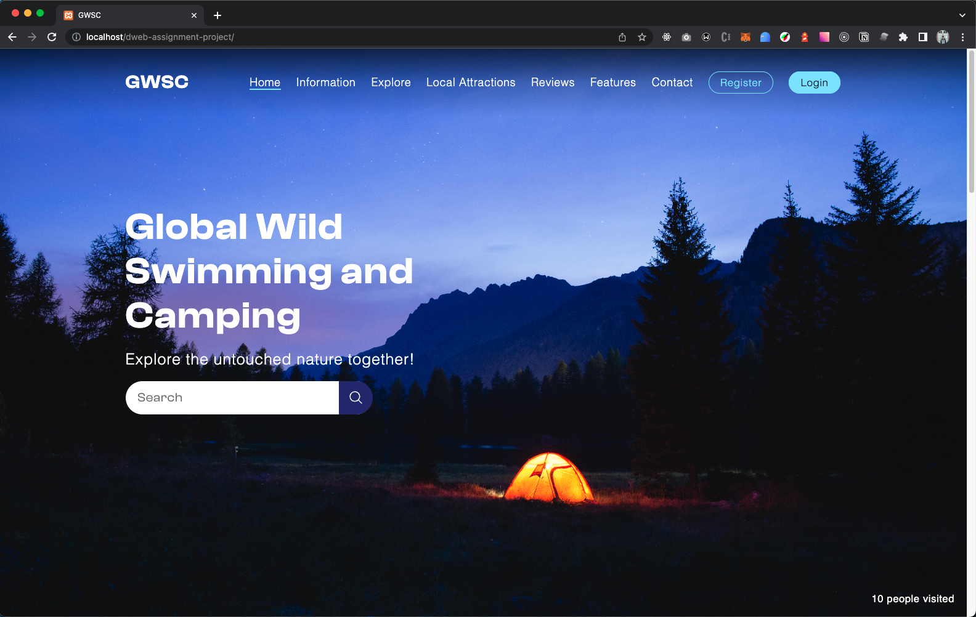

The home page contains:

* Background image slider that showing relevant images
* Search bar
* Visitor counter
* Simple and relevant text
* Popular Pitch types
* Popular campsites sorted by rating

## Information

Information page includes:

* Pitch types along with description and availability
* Locations of the campground redirected to google map when clicked
* Summary of Local attractions

(Wikipedia, 2023)

## Pitch Types and Availability

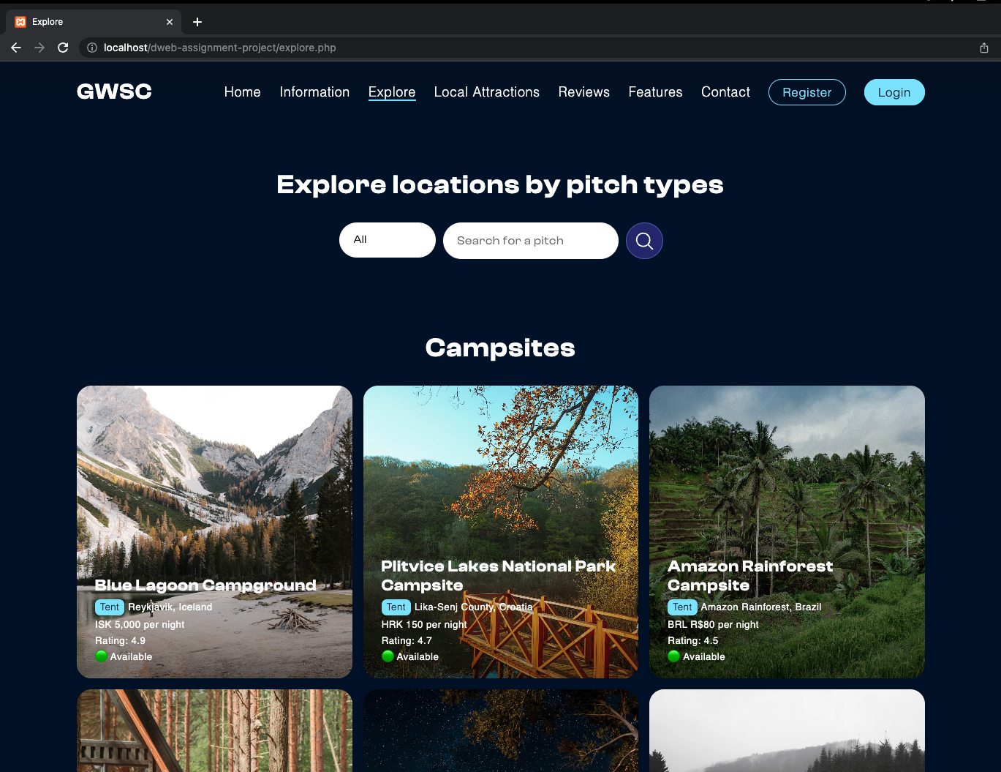

I renamed this page to ‘Explore’ since it is more relevant according to functionality.

This page includes:

* Listing of campsites along with their details
  + Pitch type
  + Price
  + Rating
  + Availability
* Functionality to search by pitch type
* Functionality to search by name or location
* Functionality to search by pitch type and name or location

## Reviews

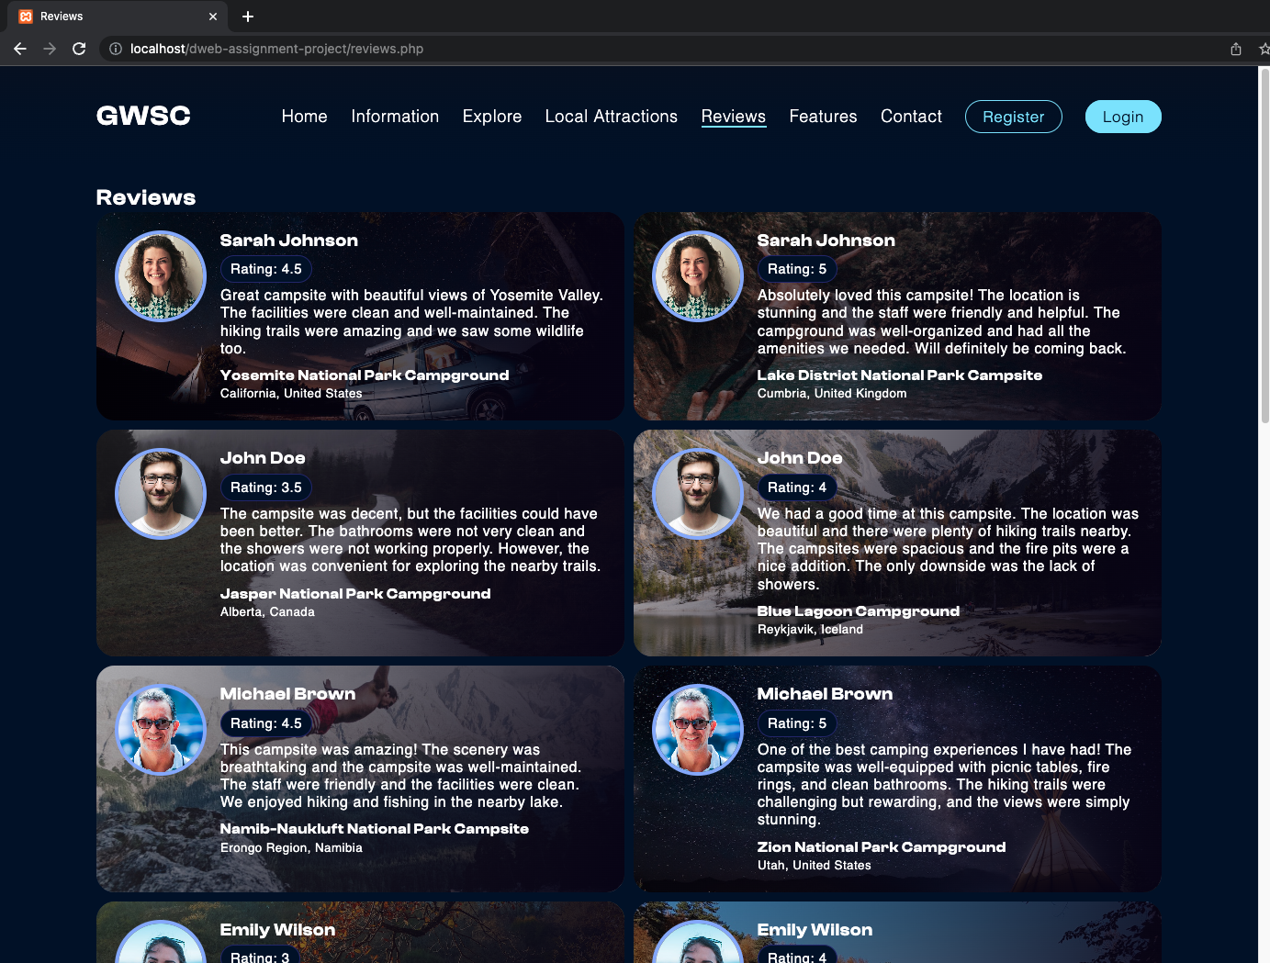

The review page includes listing of reviews by customer to campsite that contain:

* Customer name
* Customer rating
* Review message
* Campsite name
* Campsite location
* Images of customer and campsite

## Features

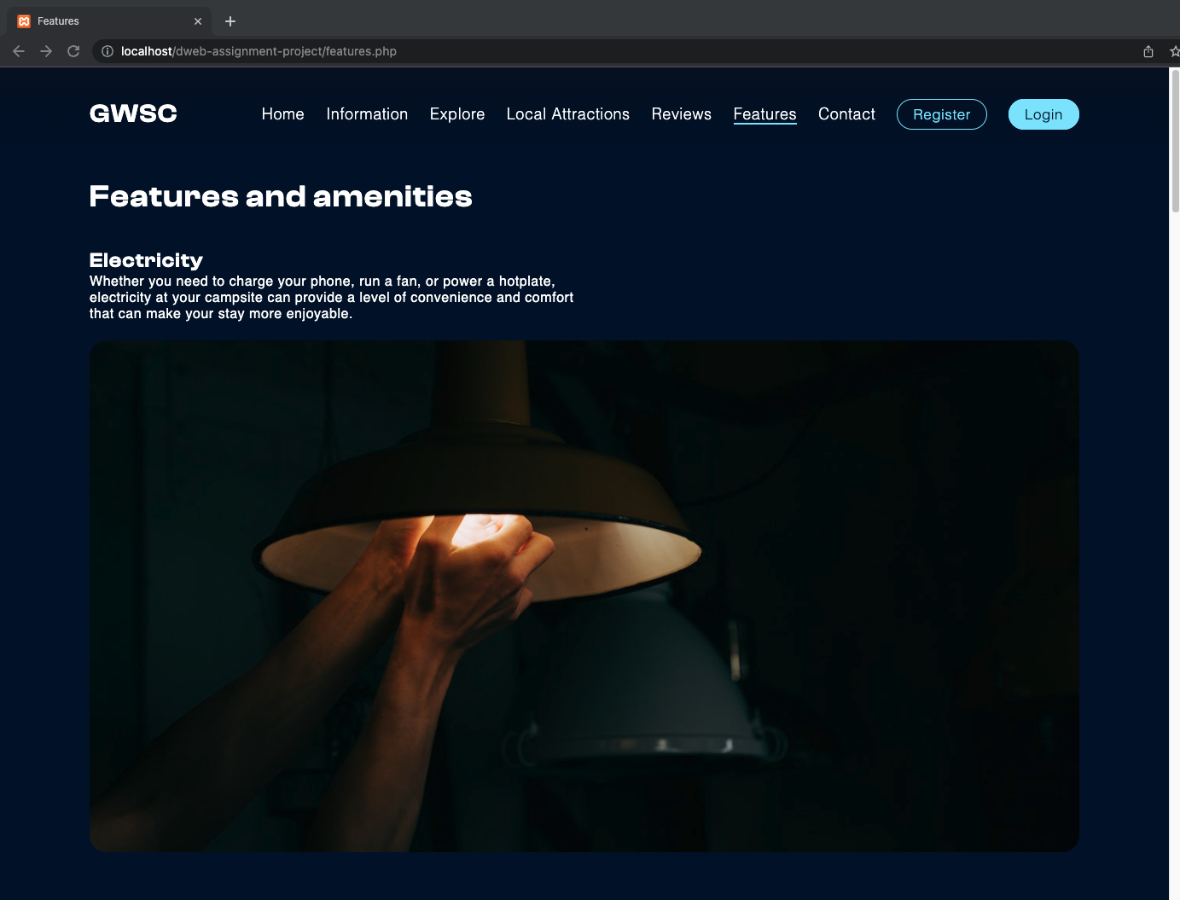

This page includes features and amenities.

## Contact

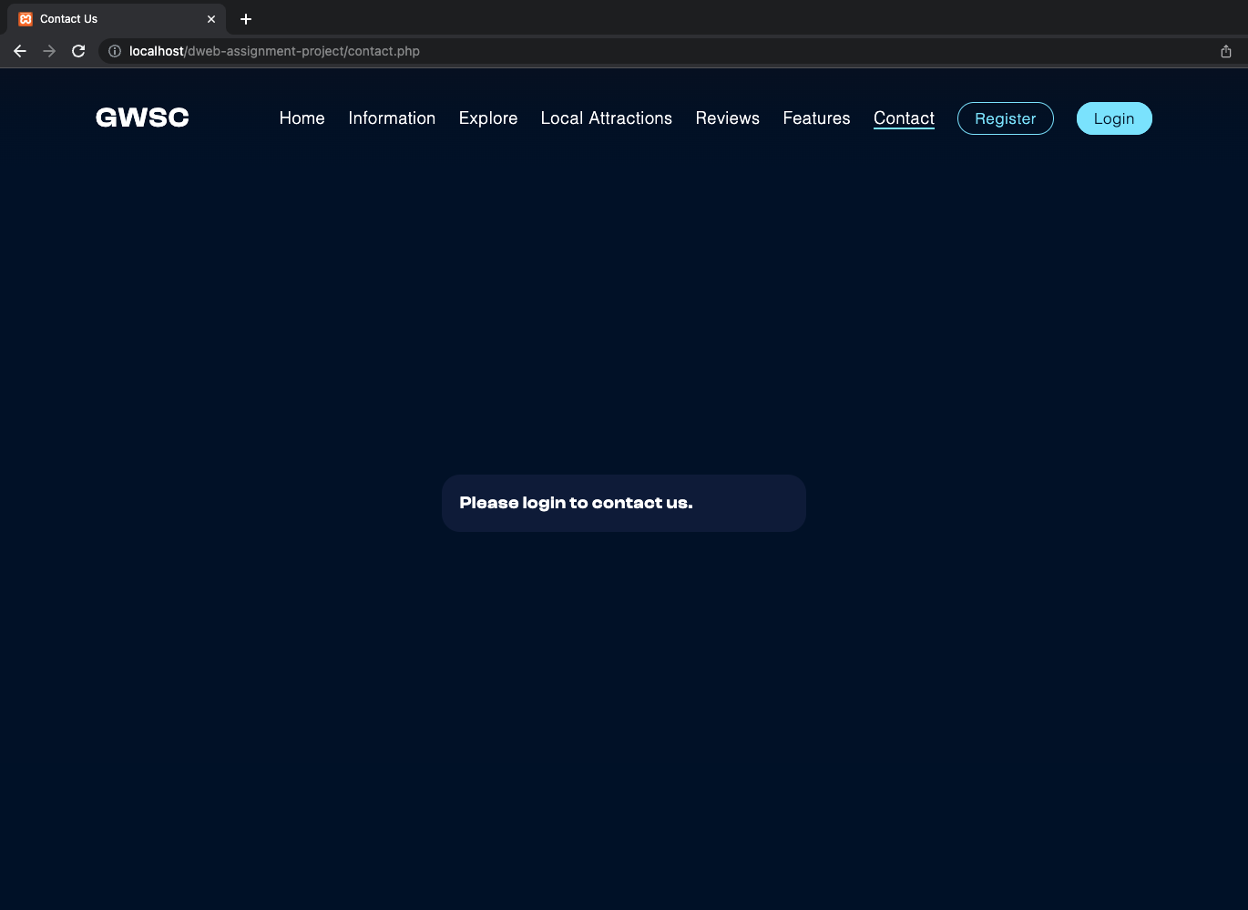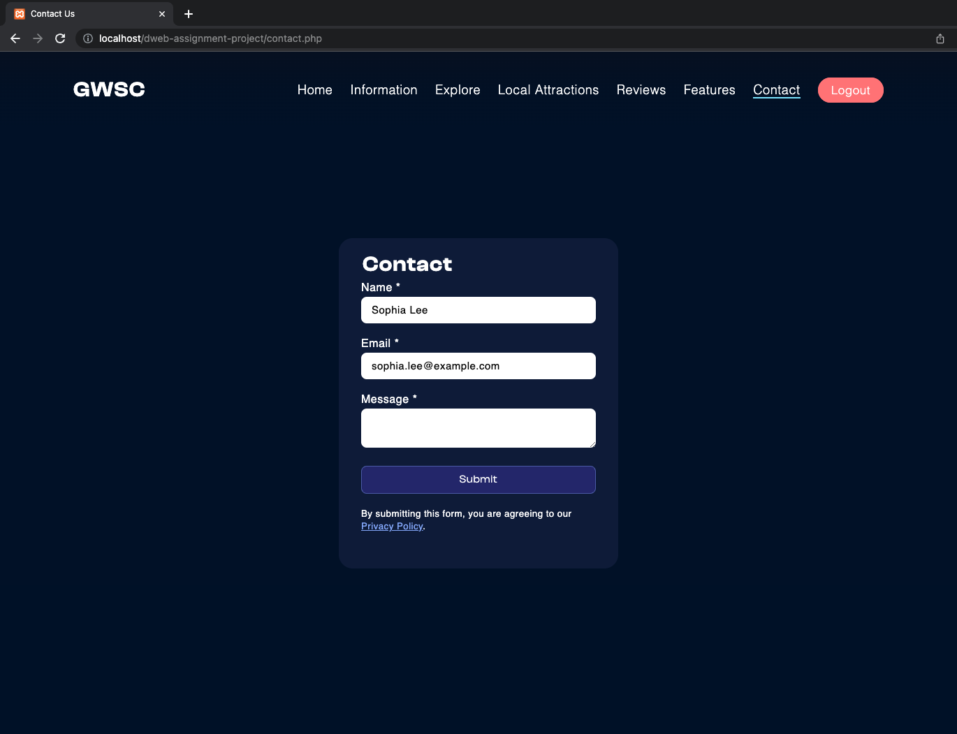Before Login:

After Login: (Name and email auto prefilled)

Contact form submitted:

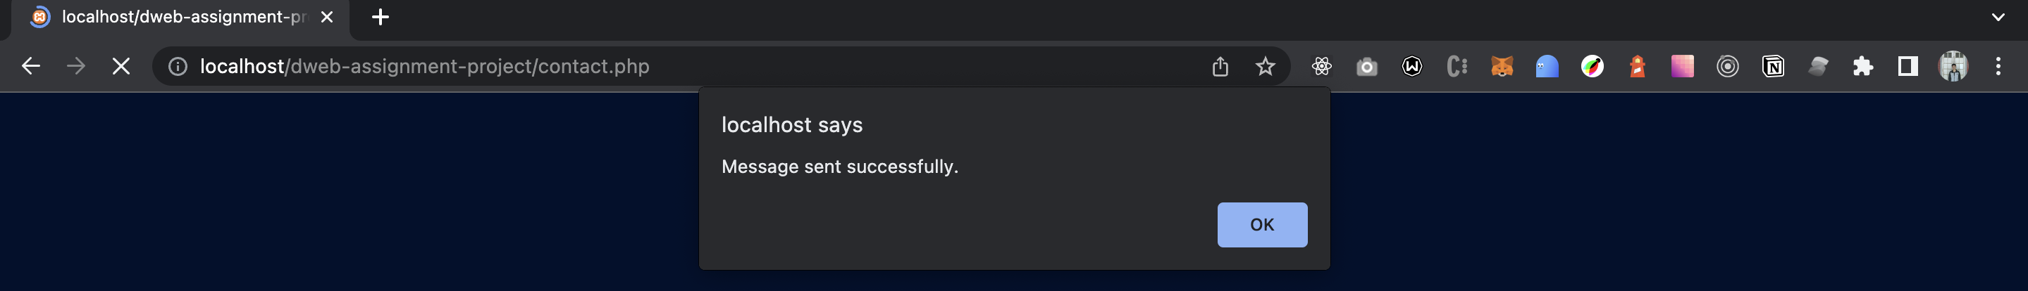

Privacy Policy:

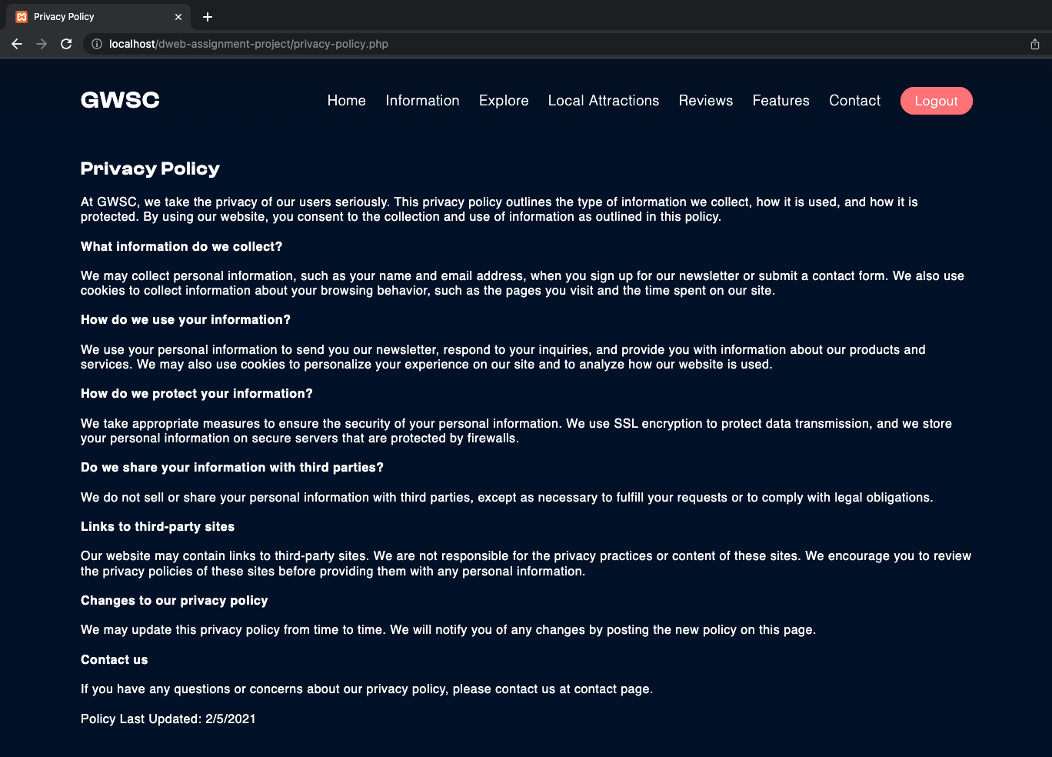

Contact form can only be submitted by login-ed customers. When a login-ed customer visit to contact for his/her name and email is prefilled. Privacy Policy note is shown with a link to detail Privacy Policy page.

## Local Attractions

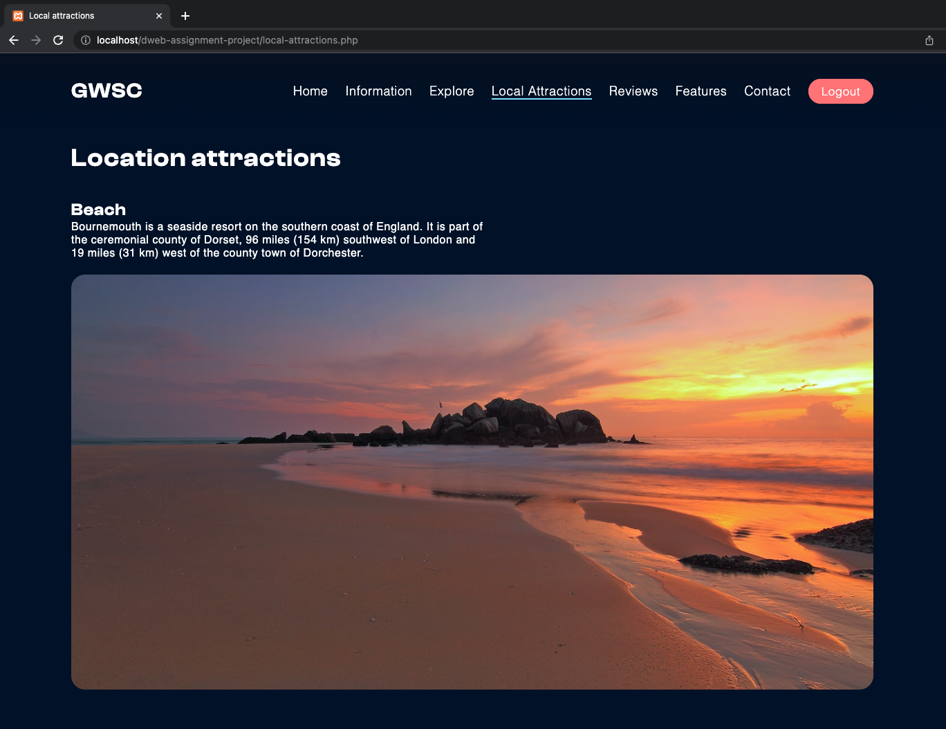

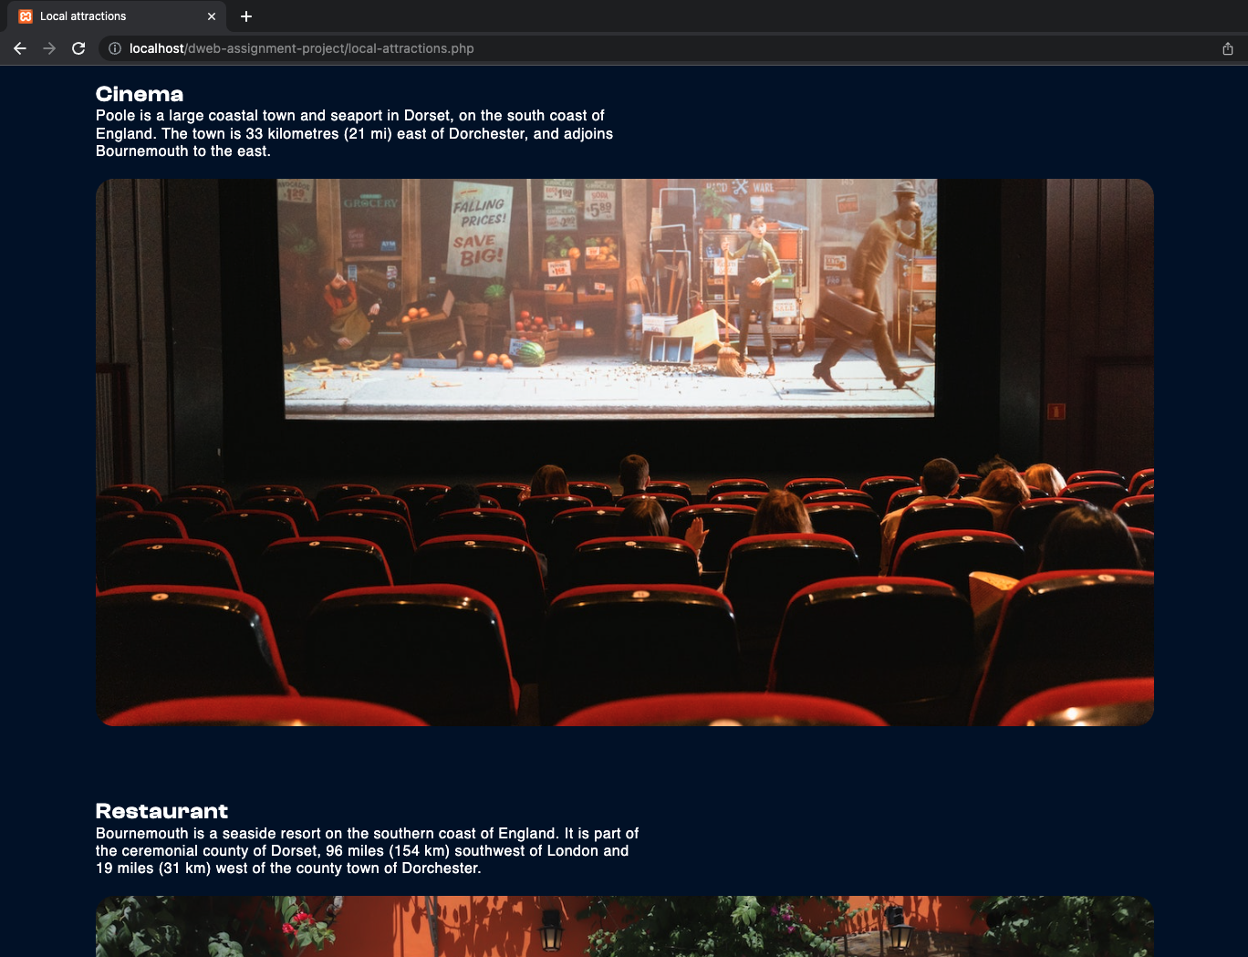

This page contains local attractions of different types.

## Login Page

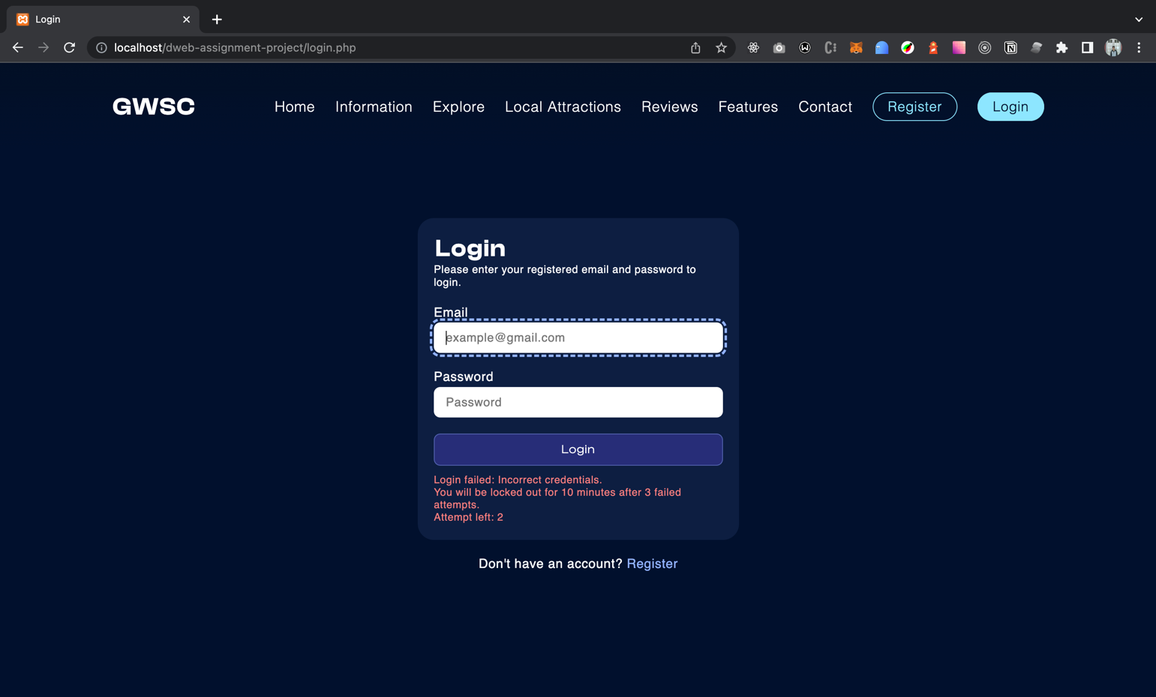Failed login

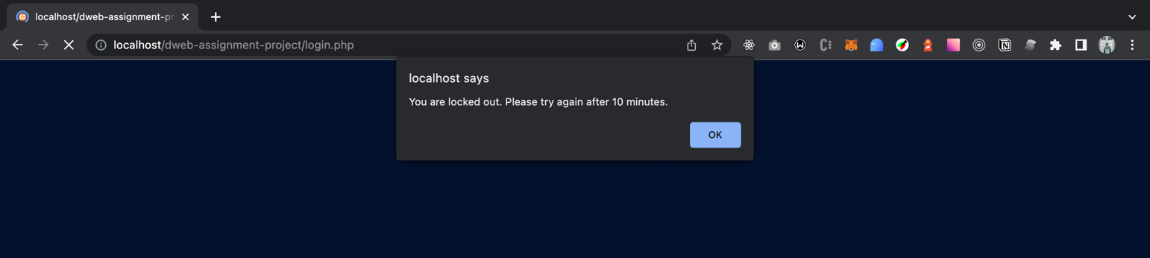Locked out for 10 minutes after 3 attempts

Login success (redirect to home page)

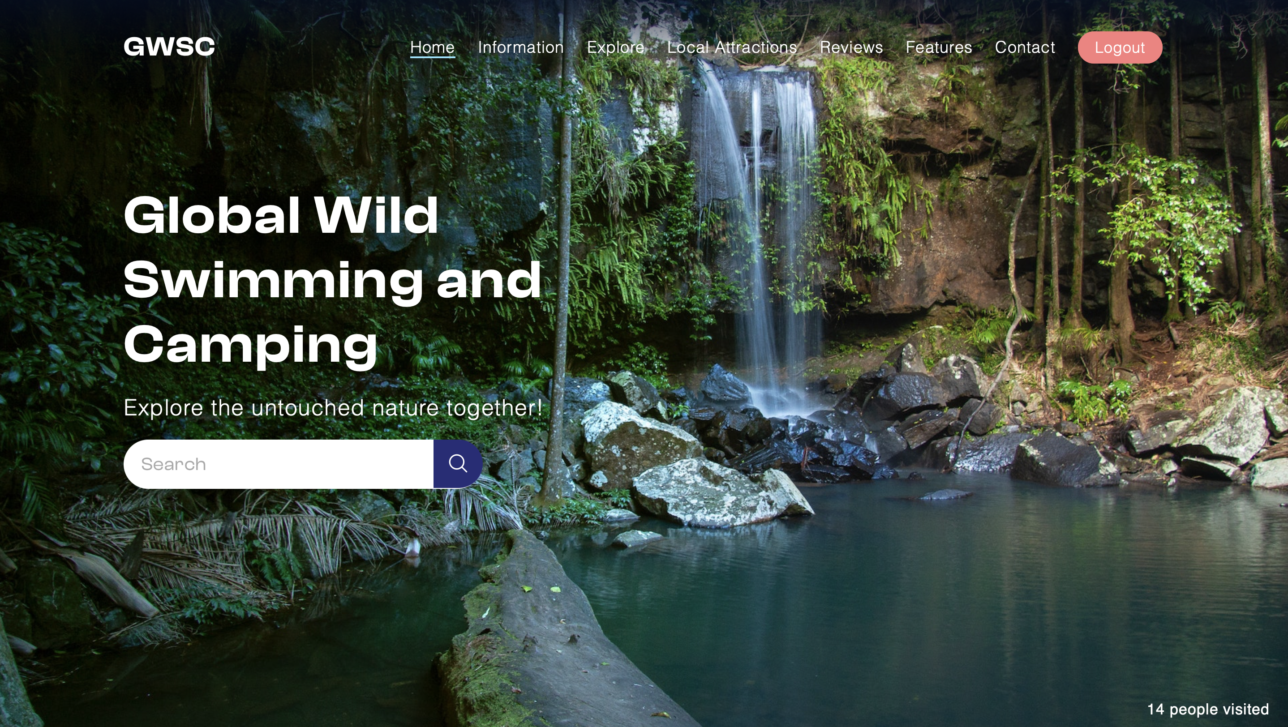

Logout confirmation



## Register Page

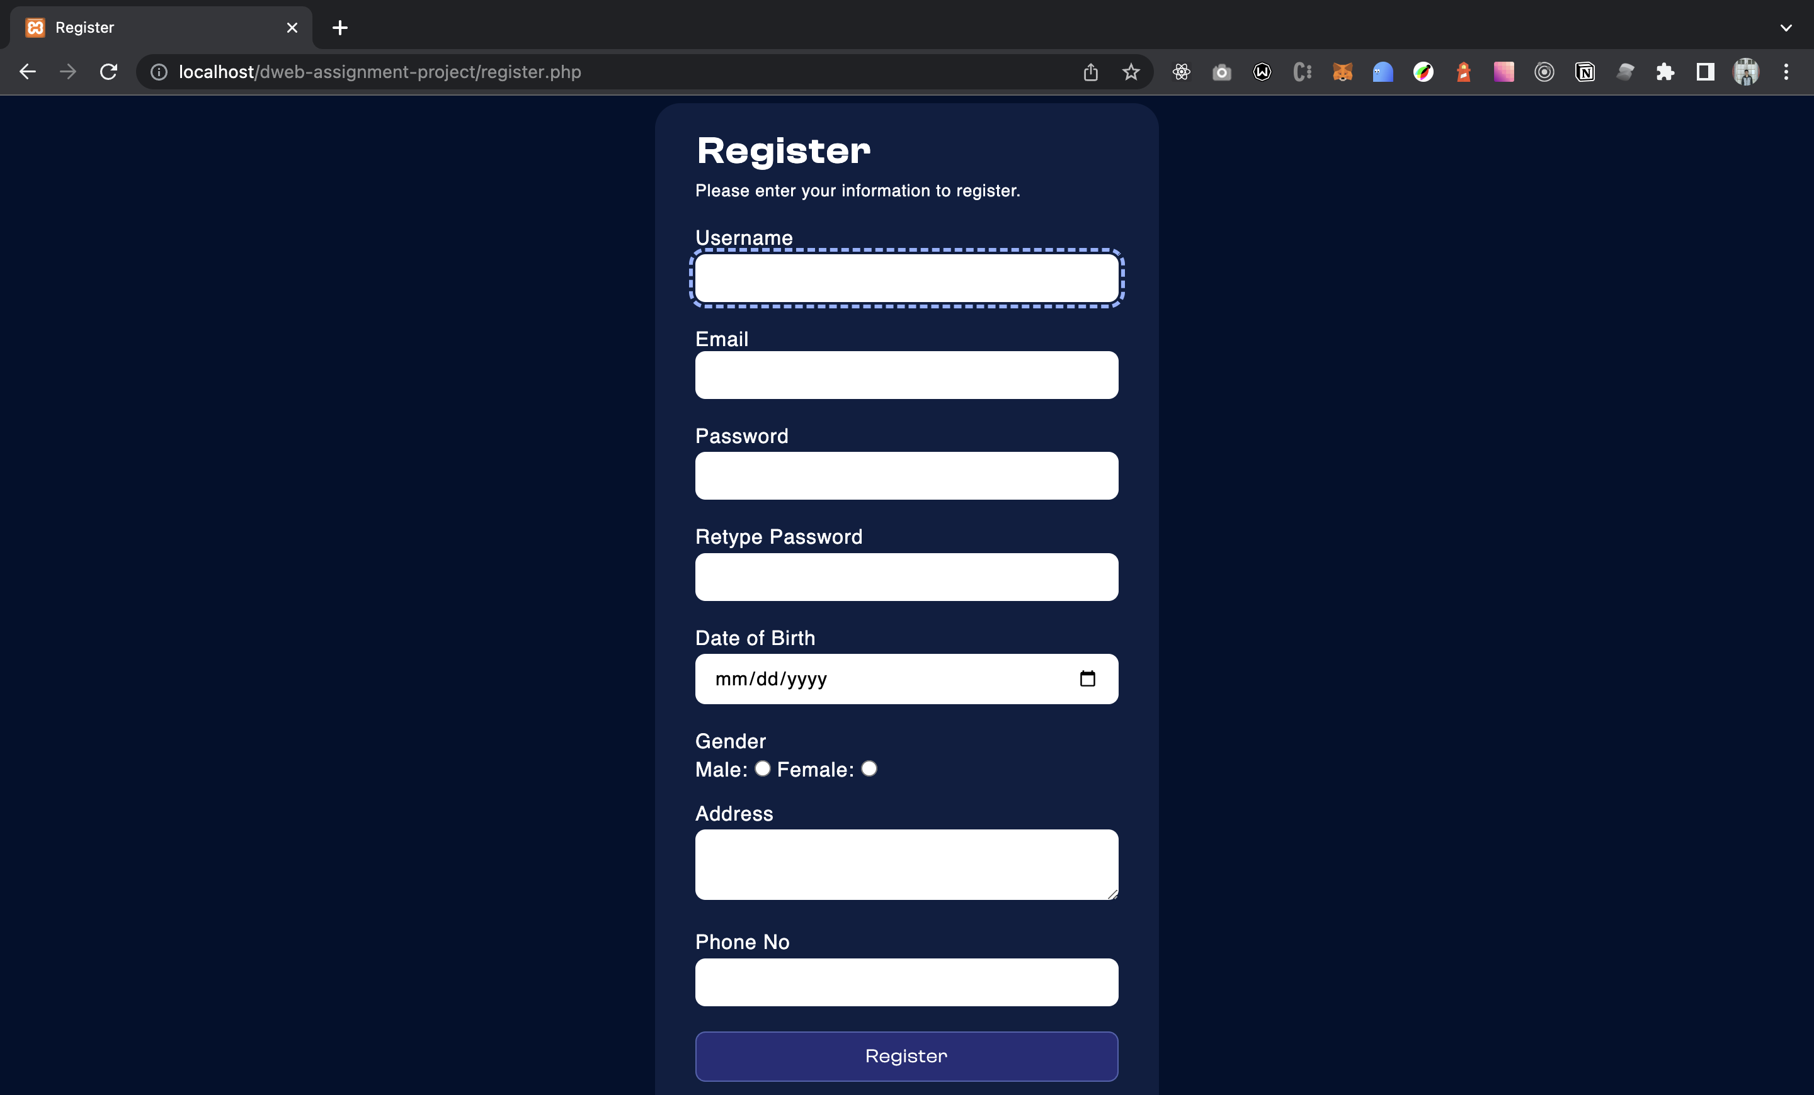

Password do not match

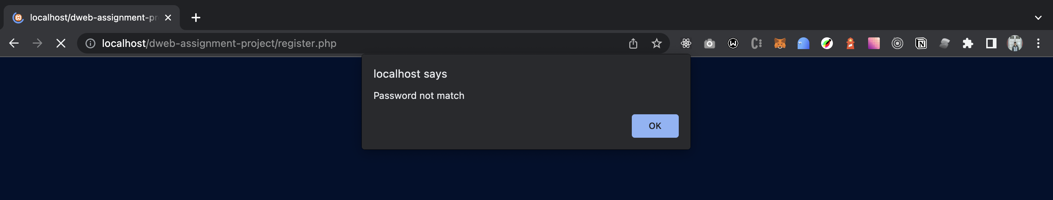

Email already exists (Tried with existing email)

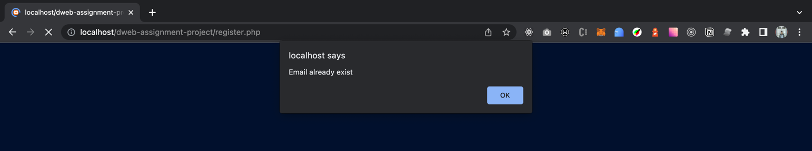

(Government, 2023)Success

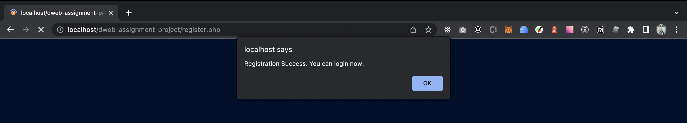

## Cross Platform and Cross Browser Usability

Google Chrome – Version 112.0.5615.137

Mac Safari – Version 16.3

iOS Safari – iOS Version 16.4

### Home Page

Google Chrome

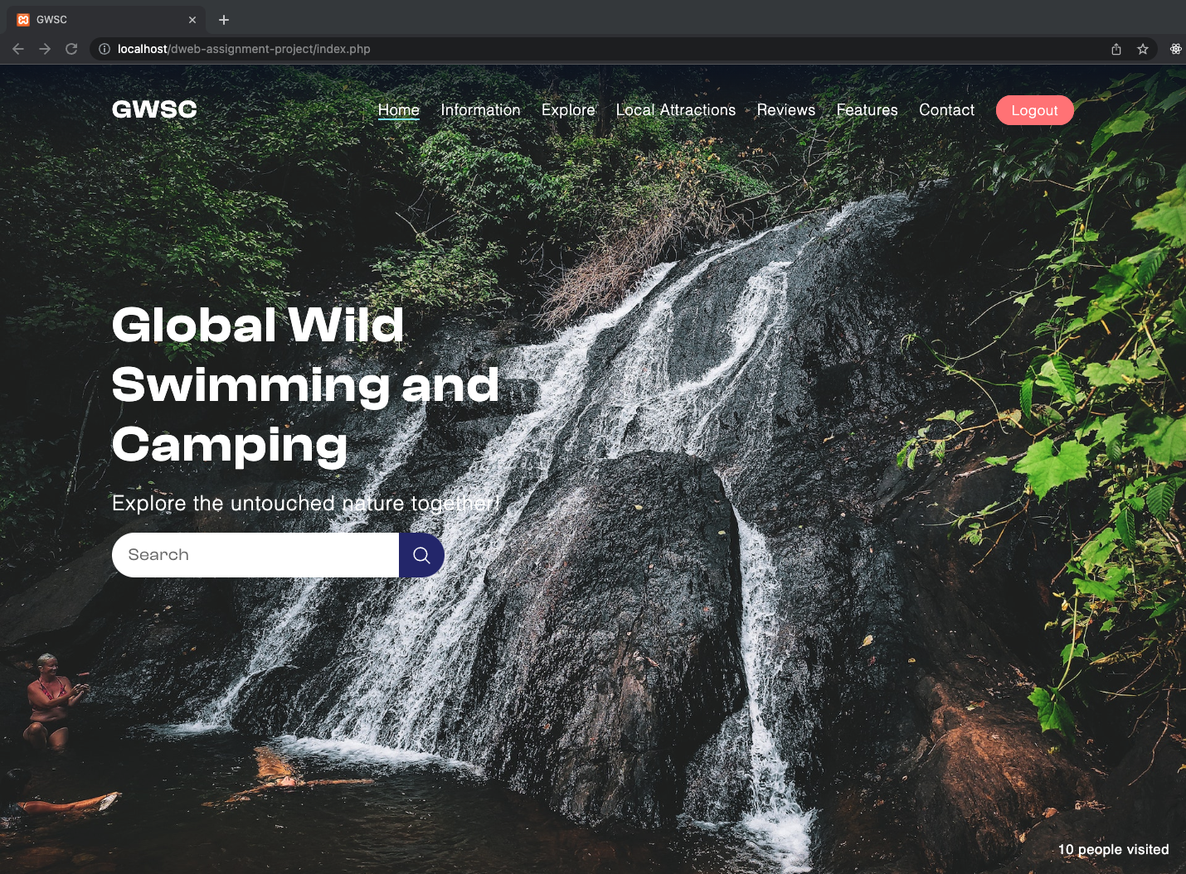

Mac Safari

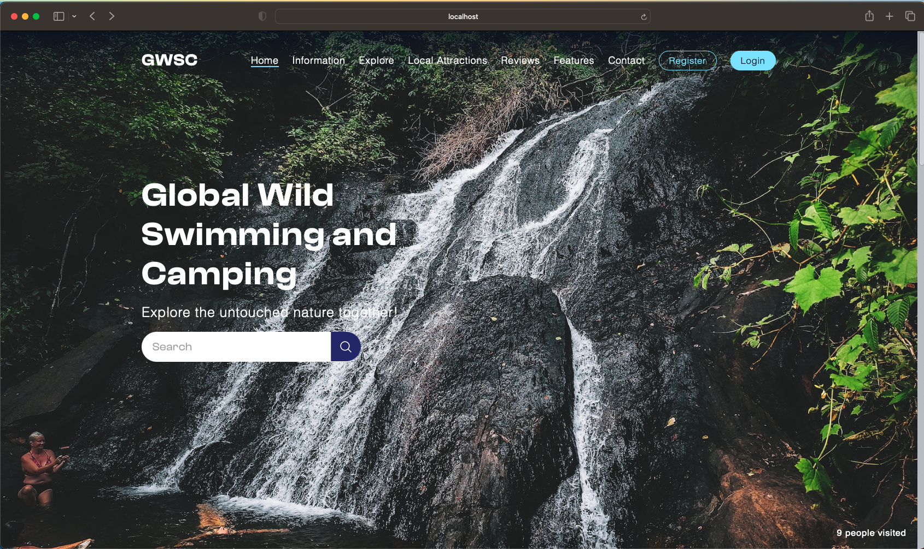

iOS

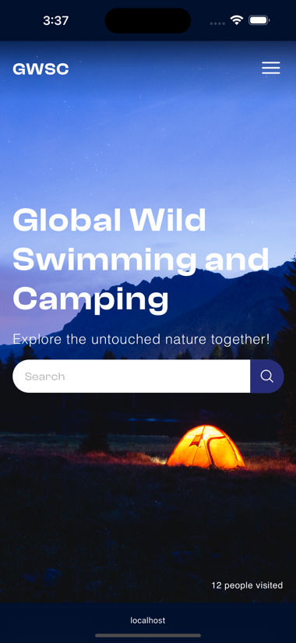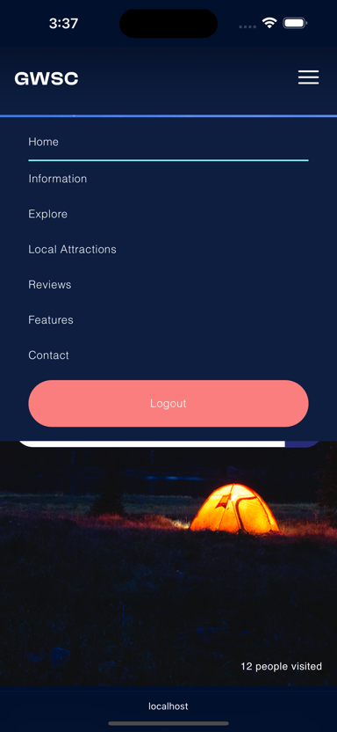

### Pitch types & Availability (Explore)

Google Chrome

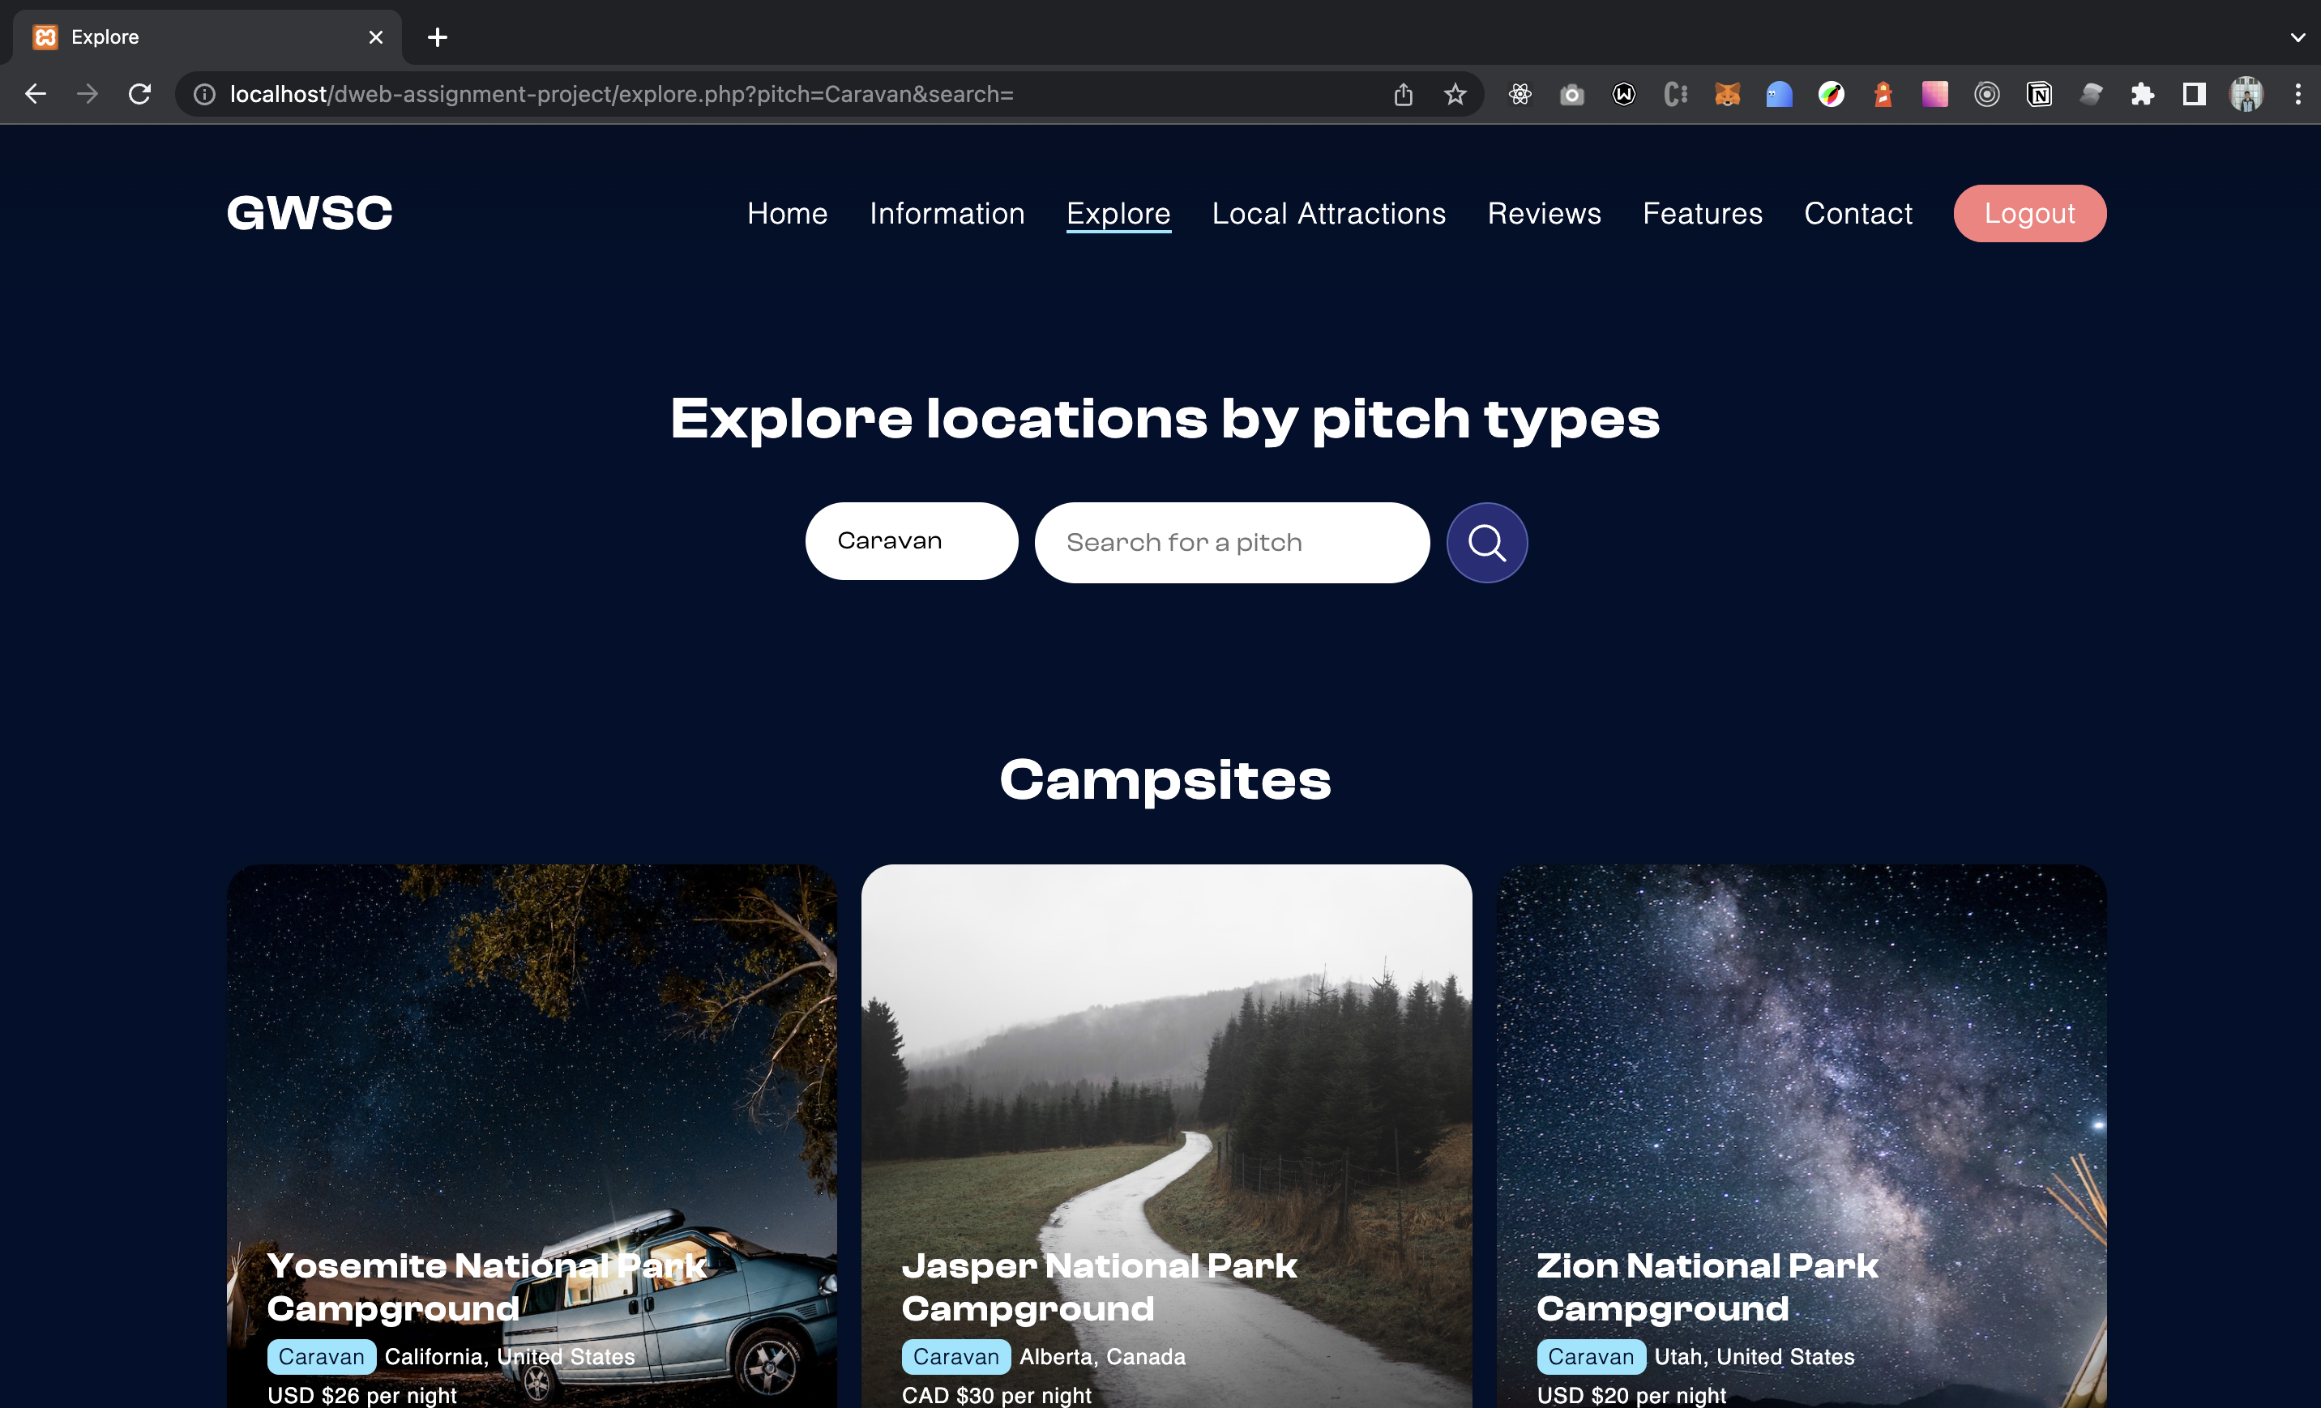

Mac Safari

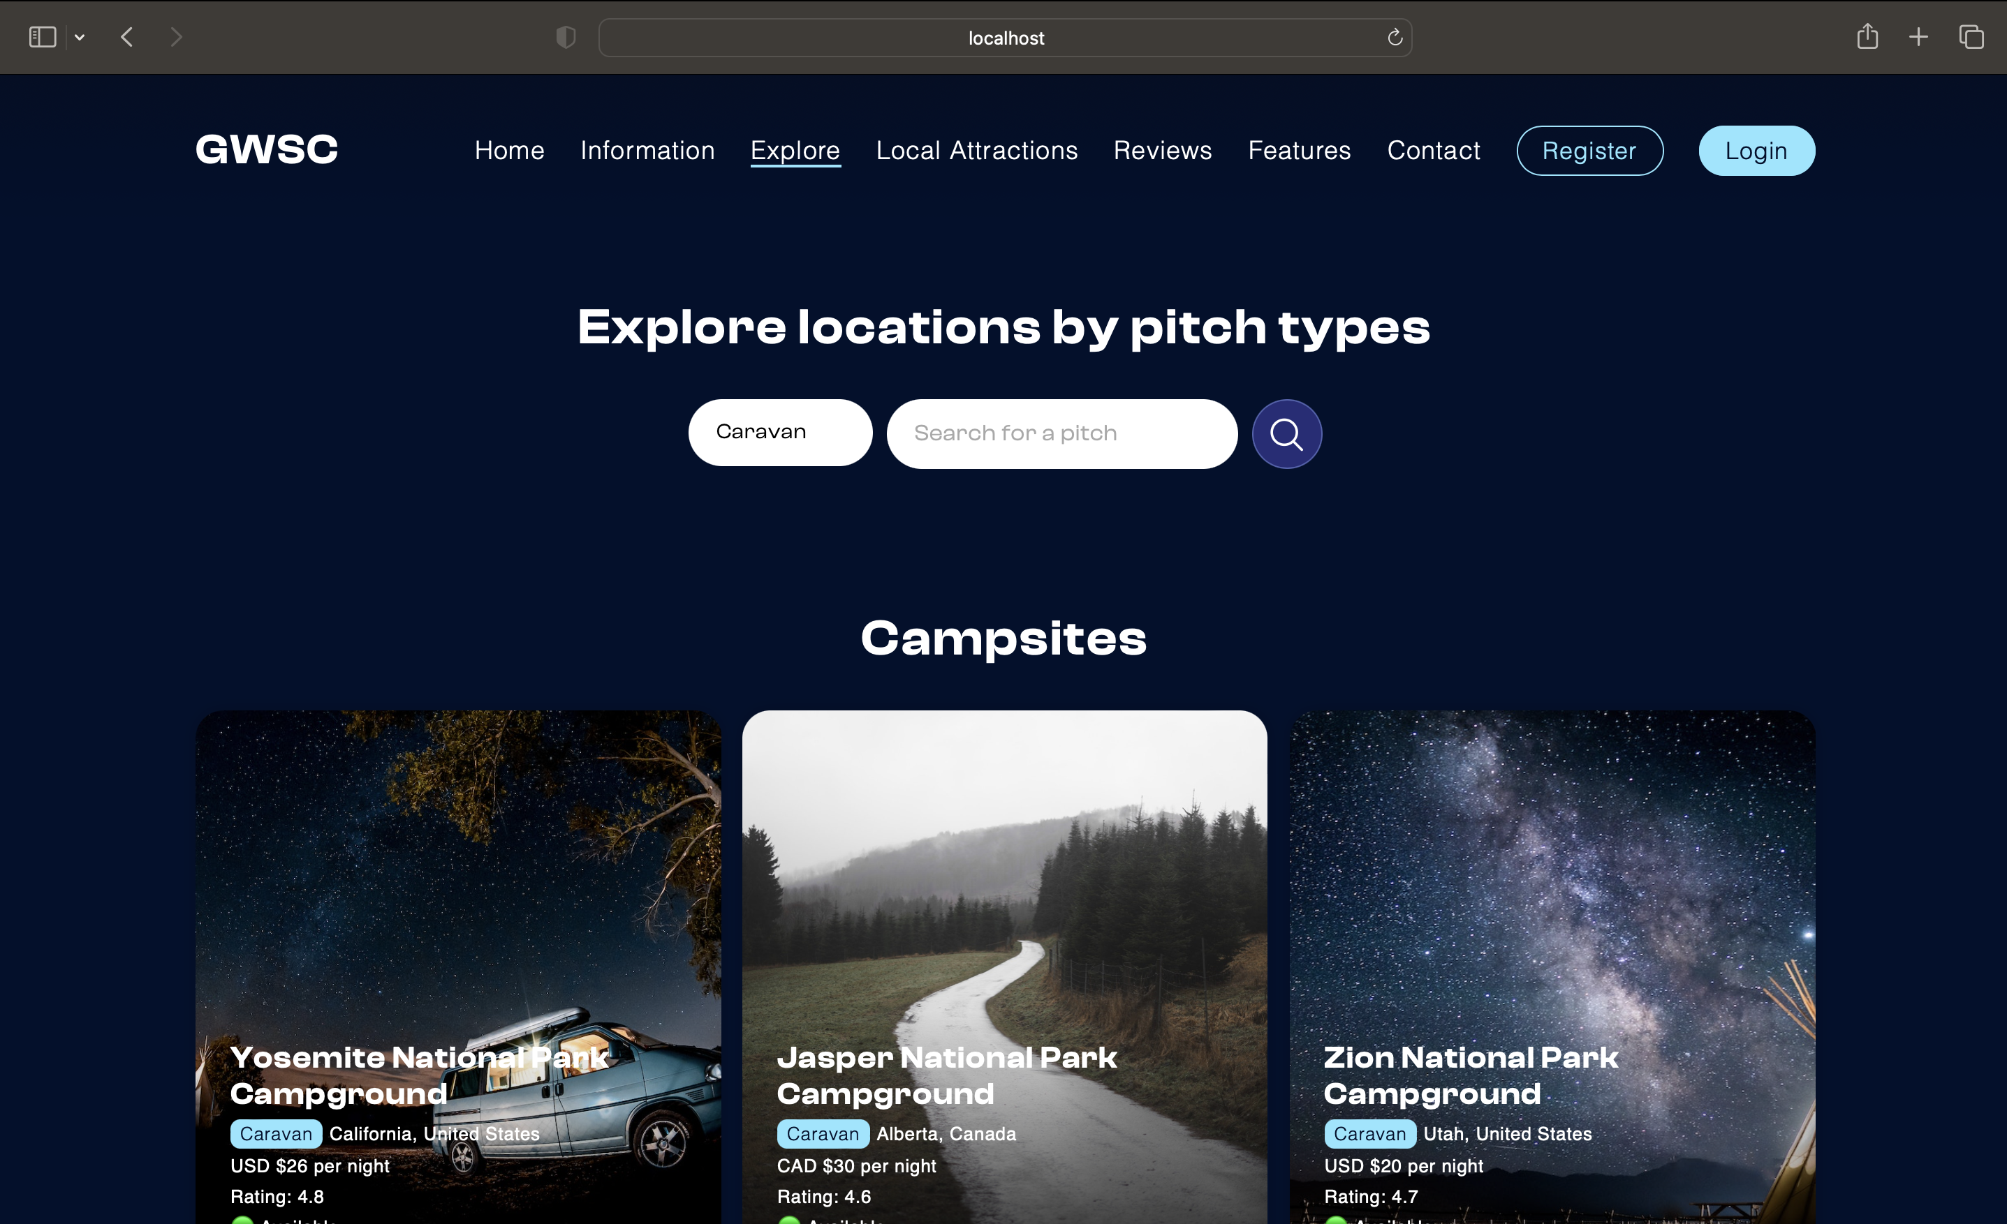

iOS Safari

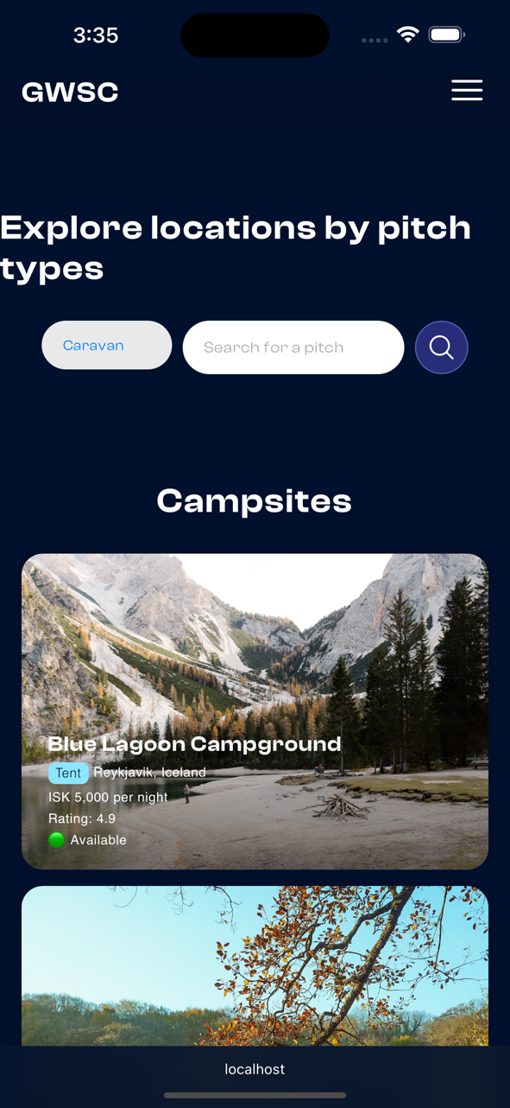

### Contact form

Google Chrome

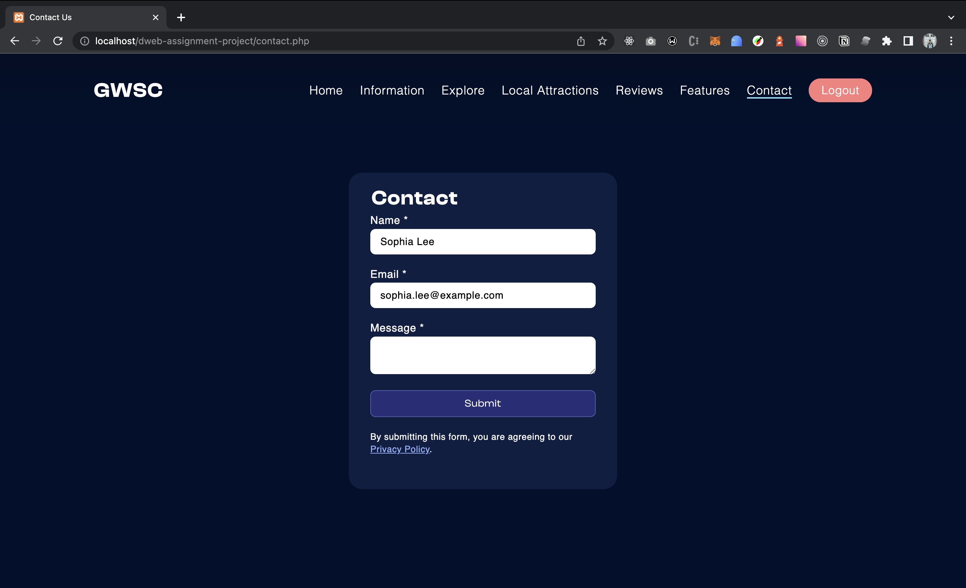

Mac Safari

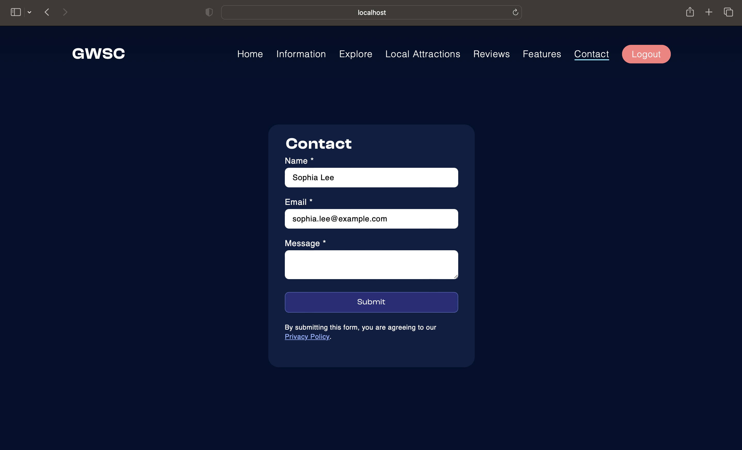

iOS Safari

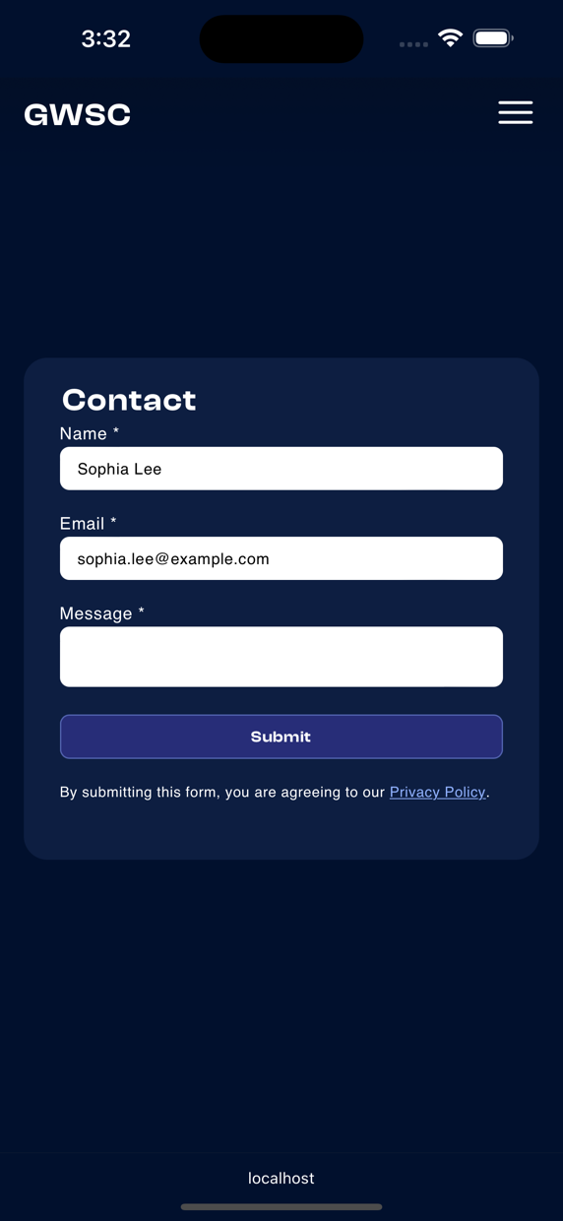

# Task 2 – CSS and Database

## CSS

## Data Dictionary

### GWSC Info Table

|  |  |  |  |  |
| --- | --- | --- | --- | --- |
| **Column Name** | **Data Type** | **Data Size** | **Remark** | **Description** |
| visitor_count | INT | Not Null | PRIMARY KEY, DEFAULT 0 | Number of visitors to Gwsc_info table. |

### Admin Table

|  |  |  |  |  |
| --- | --- | --- | --- | --- |
| **Column Name** | **Data Type** | **Data Size** | **Remark** | **Description** |
| adminid | INT | 5 | PRIMARY KEY | Unique identifier for each admin |
| adminname | VARCHAR | 30 | NOT NULL | Name of the admin |
| email | CHAR | 50 | NOT NULL, UNIQUE | Email address of the admin |
| password | CHAR | 150 | NOT NULL | Password for the admin account |
| address | VARCHAR | 100 | NOT NULL | Address of the admin |
| phoneno | VARCHAR | 30 | NOT NULL | Phone number of the admin |

### User Table

|  |  |  |  |  |
| --- | --- | --- | --- | --- |
| **Column Name** | **Data Type** | **Data Size** | **Remark** | **Description** |
| userid | INT | 5 | PRIMARY KEY, AUTO_INCREMENT | Unique identifier for each user |
| username | VARCHAR | 30 | NOT NULL | Name of the user |
| email | CHAR | 50 | NOT NULL, UNIQUE | Email address of the user |
| password | CHAR | 150 | NOT NULL | Password for the user account |
| dateofbirth | DATE |  | NOT NULL | Date of birth of the user |
| gender | VARCHAR | 10 | NOT NULL | Gender of the user |
| address | VARCHAR | 100 | NOT NULL | Address of the user |
| phoneno | VARCHAR | 30 | NOT NULL | Phone number of the user |

### Pitch Table

|  |  |  |  |  |
| --- | --- | --- | --- | --- |
| **Column Name** | **Data Type** | **Data Size** | **Remark** | **Description** |
| pitchid | INT | 5 | PRIMARY KEY, AUTO_INCREMENT | Unique identifier for each pitch |
| pitchname | VARCHAR | 200 | NOT NULL | Name of the pitch |
| availability | INT | 1 | NOT NULL | Indicates if the pitch is available or not (0 or 1) |
| description | TEXT |  |  | Description of the pitch |

### Feature Table

|  |  |  |  |  |
| --- | --- | --- | --- | --- |
| **Column Name** | **Data Type** | **Data Size** | **Remark** | **Description** |
| featureid | INT | 5 | PRIMARY KEY, AUTO_INCREMENT | Unique identifier for each feature |
| featurename | VARCHAR | 200 | NOT NULL | Name of the feature |
| description | TEXT |  |  | Description of the feature |

### Local Attraction Table

|  |  |  |  |  |
| --- | --- | --- | --- | --- |
| **Column Name** | **Data Type** | **Data Size** | **Remark** | **Description** |
| localid | INT | 5 | PRIMARY KEY, AUTO_INCREMENT | Unique identifier for each local attraction |
| localname | VARCHAR | 200 | NOT NULL | Name of the local attraction |
| location | VARCHAR | 200 | NOT NULL | Location of the local attraction |
| description | TEXT |  |  | Description of the local attraction |

### Camping Site

|  |  |  |  |  |
| --- | --- | --- | --- | --- |
| **Column Name** | **Data Type** | **Data Size** | **Remark** | **Description** |
| campsiteid | INT | 5 | PRIMARY KEY, AUTO_INCREMENT | Unique identifier for each camping site |
| sitename | VARCHAR | 200 | NOT NULL | Name of the camping site |
| location | VARCHAR | 200 | NOT NULL | Location of the camping site |
| description | TEXT |  | NOT NULL | Description of the camping site |
| pitchid | INT | 5 | NOT NULL, FOREIGN KEY (pitchid) REFERENCES pitch(pitchid) | ID of the pitch associated with the camping site |
| price | VARCHAR | 50 | NOT NULL | Price of the camping site |
| rating | DECIMAL | 3, 1 | NOT NULL | Rating of the camping site, on a scale of 0 to 10 |
| maplink | TEXT |  | NOT NULL | Link to the map of the camping site's location |

### Contact Table

|  |  |  |  |  |
| --- | --- | --- | --- | --- |
| **Column Name** | **Data Type** | **Data Size** | **Remark** | **Description** |
| name | VARCHAR | 30 | NOT NULL | Name of the person who contacted |
| email | VARCHAR | 50 | NOT NULL | Email address of the person who contacted |
| message | TEXT |  | NOT NULL | Message sent by the person who contacted |

### Review Table

|  |  |  |  |  |
| --- | --- | --- | --- | --- |
| **Column Name** | **Data Type** | **Data Size** | **Remark** | **Description** |
| reviewid | INT | 5 | PRIMARY KEY, AUTO_INCREMENT | Unique identifier for each review |
| userid | INT | 5 | NOT NULL, FOREIGN KEY(user) | Identifier of the user who made review |
| rating | FLOAT |  | NOT NULL | The rating given by the user |
| review | TEXT |  | NOT NULL | Text of the review |
| campsiteid | INT | 5 | FOREIGN KEY(camping_site), nullable | Identifier of the campsite being reviewed |

# Task 3 – Critical Evaluation

## Introduction

The importance of having an online presence for organizations has become essential in the current digital world. A new company called Global Wild Swimming and Camping (GWSC) is creating an online e-commerce website in an effort to attract a wider audience than just the neighborhood. In this report, I'll examine the website that GWSC created using HTML, CSS, PHP, and MySQL and assess how well it satisfies the scenario's goals.

## Benefits of web services and how they add functionality to the website

Modern web development now relies heavily on web services. They offer a communication interface for many programs to interact with one another online, increasing functionality and flexibility. Web services have been created to provide certain functionality, such as a contact form, authentication, view counter, and RSS feed, on the GWSC website. First, a user-friendly online contact form has been created so that website visitors may communicate with the business. Using MySQL and PHP's built-in web services, I also developed login and registration. When a visitor visits the home page, an ajax web service is also employed to increase the number of views. To enable users to subscribe to website updates, an RSS feed has been provided. The user experience, consumer engagement, and functioning of the website are all improved by these web services, which are very beneficial to GWSC.

## Effectiveness of using x(HTML)

The website's structure and content are determined by HTML, which serves as the website's basis. The newest form of HTML, HTML5, is used on the website created for GWSC. The creation of a more semantic, user-friendly, and interactive website has been made possible by the usage of HTML5. The website efficiently utilizes HTML to construct interactive components like the search bar, navigation, media sources, and contact form as well as to organize material and deliver media content. The website uses responsive design strategies as well to improve content presentation on various devices. In order to create a website that is aesthetically pleasing, interactive, and accessible, HTML5 has proved beneficial.

## Effectiveness of using CSS

The website created for GWSC effectively utilizes CSS3 to offer an aesthetically pleasing and unified user interface. A responsive design that adjusts to various screen sizes and offers the best viewing experience on all devices has been created using CSS. The website has a unified appearance and feel because to the usage of a uniform color palette, font, and layout on all pages. These have been accomplished by utilizing CSS variables throughout the styles. Designing responsive layouts, text sizes, and graphics also makes advantage of CSS contemporary capabilities like auto-fit grid and media query. As a result, the usage of CSS has helped to standardize the generated website and create a user experience that is both visually appealing and consistent.

## Effectiveness of using PHP and MySQL

PHP provides a powerful method for creating dynamic content. The majority of the features rely on PHP. The website uses MySQL to manage the database, which stores all GWSC information such as user profiles, pitch information, camping data, and customer reviews. Because PHP includes MySQL functionality and utilities by default, developing dynamic content for GWSC is simpler and faster. SQL makes data administration more efficient while also ensuring that the data is correct and consistent. Prepared statements and parameterized queries are used to defend the website against SQL injection attacks.

## Evaluation of how the utilisation of web services meets the objectives

The website has seven pages: a home page, an explore page, an information page, a contact us page, a local attractions page, a reviews page, and a feature page. It is mobile-friendly, with responsive pictures that adjust to various screen sizes and resolutions. The website achieves its objectives by providing potential clients with rapid access to information about GWSC's facilities and services. The explore page offers available pitch types and campsites, whilst the main page provides an overview of GWSC's services. The feature page provides information on the facilities and amenities available, while the information page goes into great detail on the many types of pitches and camping sites, along with Google redirection and area attractions. The contact us and reviews sections make it easier for GWSC to engage with consumers and become more engaging.

The website's design is simple and uncomplicated. I utilize fashionable dark colours for the background to give it a camping vibe while also making the visual style pleasing to the eye. The use of contemporary HTML and CSS services ensures that the website looks good on a wide range of devices and screen sizes. The home page satisfies the requirement because it has a search bar, an image slider containing relevant images, and a visitor counter. Because the explore page provides more search controls, I developed the search function to redirect and search in the explore page when submitted. Ajax web service is also used to implement the visitor counter. It is utilized since it only increases the count if the user has visited the page. This is ensured by using JavaScript (client side), which is only executed in the browser after the web content has been shown.

To implement login and registration functions, I utilize PHP and MySQL. The register function verifies the existing user's email address and determines whether the two passwords are the same. Passwords saved in the database are hashed for security. I also utilize the current authentication session to decide the protection of the contact form page and the redirection to the home page when the login and registration pages are viewed. The login process additionally includes a lock out policy if the user enters wrong credentials three times. This is accomplished through the usage of sessions. Furthermore, I employ the benefits of dynamic data stored in a MySQL database to display practically all of the GWSC website's content and information.

Finally, the website created for GWSC using HTML, CSS, PHP, and MySQL efficiently met the objectives in the given situation. In addition, the usage of web services, HTML5, and CSS has allowed for the creation of a visually pleasing, interactive, and functional website that provides a rich user experience. As a result, the website is a tremendous asset for GWSC, providing significant benefits through improving user experience, increasing customer interaction, and expanding website capabilities.

# Task 4 – Reflection

I utilized a variety of technologies when constructing the website for Global Wild Swimming and Camping (GWSC), including Visual Studio Code, XAMPP, and PhpMyAdmin. I began by building the website framework in HTML, then added responsive design in CSS. To display the picture slider on the home page, I utilized jQuery and Slick. I was able to rapidly and efficiently generate and edit code with Visual Studio Code, and handling server-side activities such as PHP server and MySQL was simplified with XAMPP and PhpMyAdmin.

Throughout the process, I learned a lot about website building, especially how important it is to utilize the correct tools for the job. I also learned how to identify and repair problems that arose during development, such as SQL syntax mistakes that did not appear, and I gained experience with a number of languages and technologies.

I wish I had spent more work on the website's role-based views (admin and customer) and user account profile management. In the future, I'd like to use more scalable views, data retrieval and clean modularized CSS that doesn't make style overrides.

In summary, working on this project allowed me to expand my knowledge of website development, put it to use, and get acquainted with new tools and techniques that I may utilize in subsequent jobs.

# References

Government, Q., 2023. *Parks and Forest.* [Online]   
Available at: https://parks.des.qld.gov.au/  
[Accessed 25 April 2023].

Indian Type Foundry, 2021. *Clash Display - Fontshare.* [Online]   
Available at: https://www.fontshare.com/fonts/clash-display  
[Accessed 10 April 2023].

Pexels, 2023. *Discover the Best of Pexels.* [Online]   
Available at: https://www.pexels.com/discover/  
[Accessed 25 April 2023].

Pexels, 2023. *Legal Simplicity.* [Online]   
Available at: https://www.pexels.com/license/  
[Accessed 25 April 2023].

Wikipedia, 2023. *Privacy Policy.* [Online]   
Available at: https://en.wikipedia.org/wiki/Privacy_policy  
[Accessed 24 April 2023].